Time Travel in snowflake
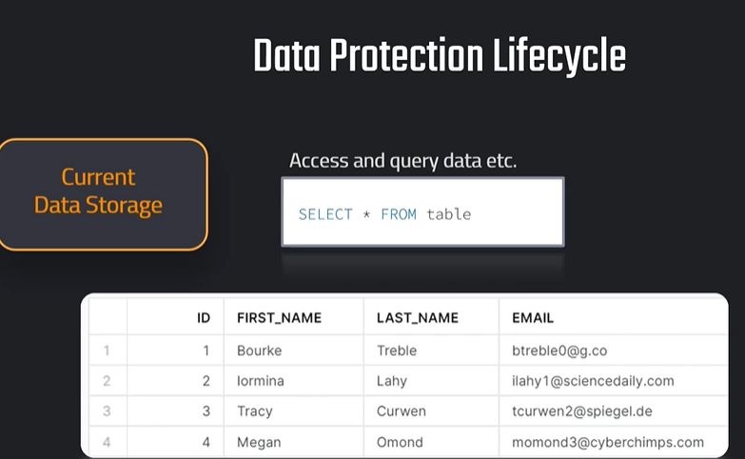

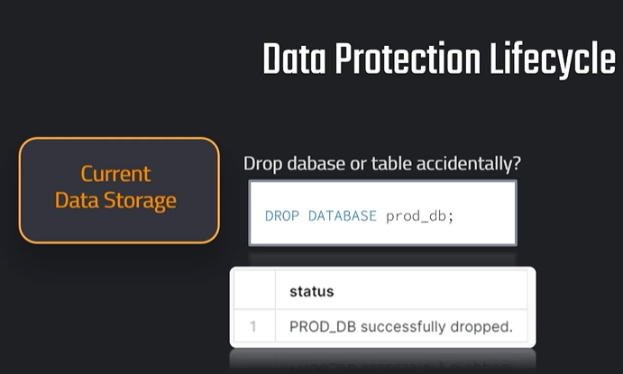

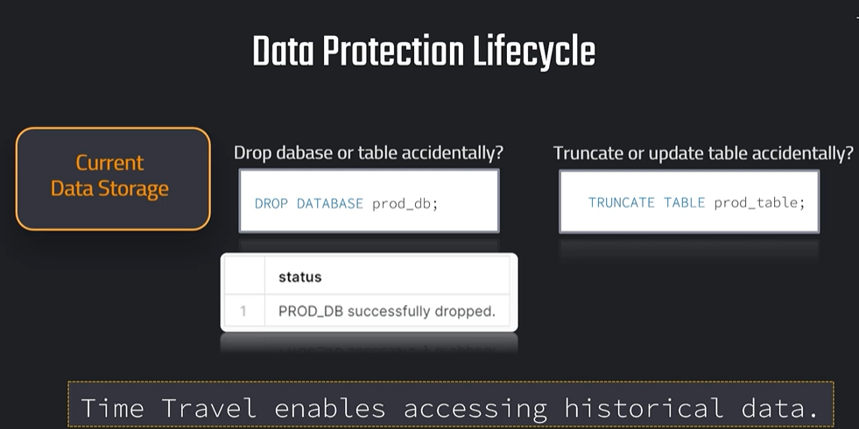

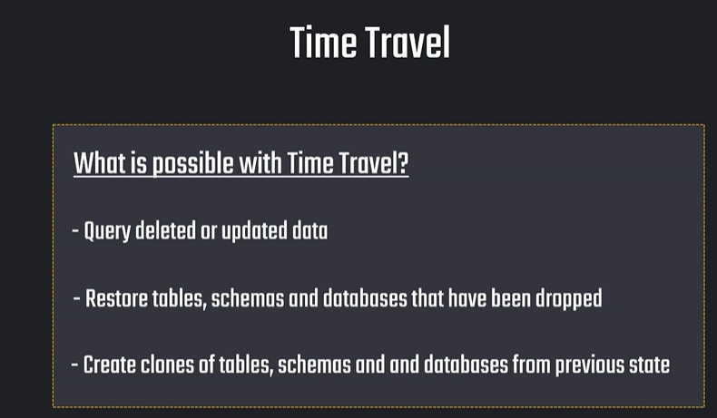

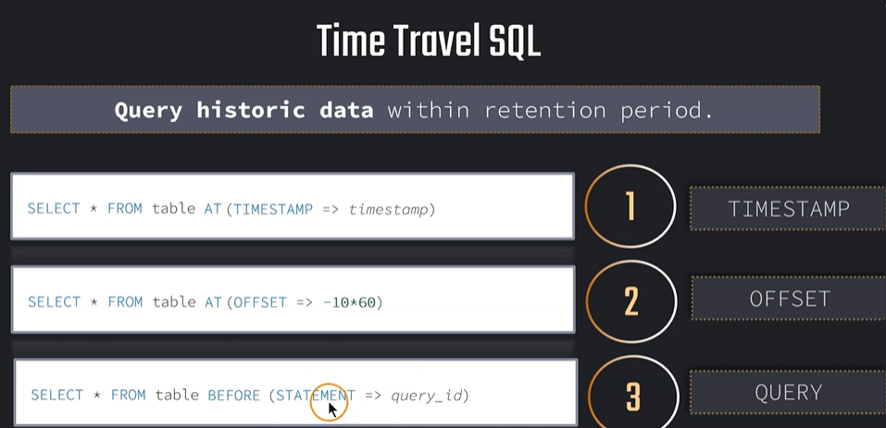

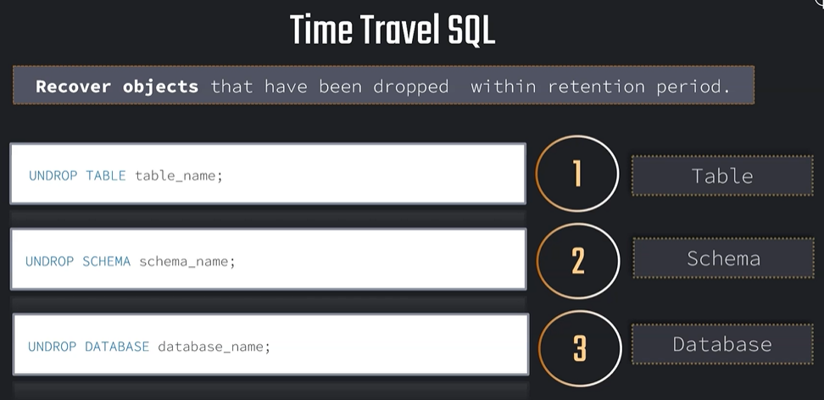
Time Travel in Snowflake is a feature used to access historical data from tables, schemas, or databases.
It helps you recover data if it was:
- Accidentally deleted
- Accidentally updated
- Dropped by mistake
- Changed incorrectly
Example
Suppose you delete records by mistake:
DELETE FROM employees;
Using Time Travel, you can query the table as it was before deletion:
SELECT *
FROM employees
AT (OFFSET => -60 * 5);
This means:
Show the employees table data as it was 5 minutes ago
Common Time Travel Syntax
1. Query data before a specific time
SELECT *
FROM employees
AT (TIMESTAMP => '2026-05-16 10:00:00');
2. Query data some minutes ago
SELECT *
FROM employees
AT (OFFSET => -300);
-300 means 300 seconds ago, or 5 minutes ago.
3. Restore dropped table
UNDROP TABLE employees;
Retention Period
In Snowflake trial or standard editions, Time Travel is usually available for 1 day.
For higher editions, it can be up to 90 days.
Real-world use case
A student or employee accidentally runs:
UPDATE customers
SET city = 'Chennai';
Now all customer cities become Chennai by mistake.
You can recover the old data using Time Travel:
CREATE OR REPLACE TABLE customers_backup AS
SELECT *
FROM customers
AT (OFFSET => -600);
This creates a backup of the table as it was 10 minutes ago.
Simple meaning
Time Travel = Snowflake’s “undo” feature for data.

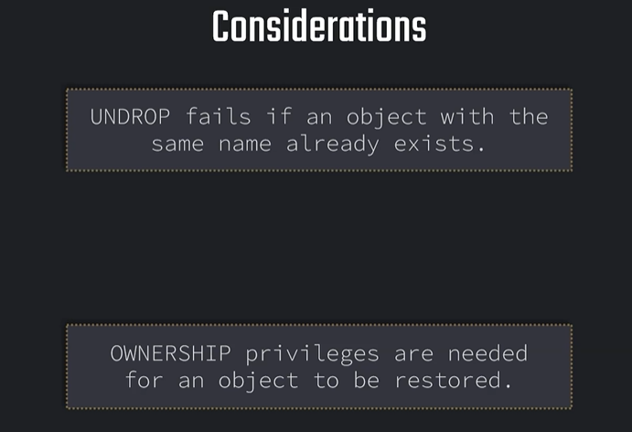

// Setting up table

CREATE OR REPLACE TABLE OUR_FIRST_DB.public.test (
id int,
first_name string,
last_name string,
email string,
gender string,
Job string,
Phone string);

CREATE OR REPLACE FILE FORMAT MANAGE_DB.file_formats.csv_file
type = csv
field_delimiter = ','
skip_header = 1;

CREATE OR REPLACE STAGE MANAGE_DB.external_stages.time_travel_stage
URL = 's3://data-snowflake-fundamentals/time-travel/'
file_format = MANAGE_DB.file_formats.csv_file;

LIST @MANAGE_DB.external_stages.time_travel_stage;

COPY INTO OUR_FIRST_DB.public.test
from @MANAGE_DB.external_stages.time_travel_stage
files = ('customers.csv');

SELECT * FROM OUR_FIRST_DB.public.test;

// Use-case: Update data (by mistake)

UPDATE OUR_FIRST_DB.public.test
SET FIRST_NAME = 'Joyen' ;

// // // Using time travel: Method 1 - 2 minutes back
SELECT * FROM OUR_FIRST_DB.public.test at (OFFSET => -60*1.5);

// // // Using time travel: Method 2 - before timestamp
SELECT * FROM OUR_FIRST_DB.public.test before (timestamp => '2021-04-15 17:47:50.581'::timestamp);

-- Setting up table
CREATE OR REPLACE TABLE OUR_FIRST_DB.public.test (
id int,
first_name string,
last_name string,
email string,
gender string,
Job string,
Phone string);

COPY INTO OUR_FIRST_DB.public.test
from @MANAGE_DB.external_stages.time_travel_stage
files = ('customers.csv');

SELECT * FROM OUR_FIRST_DB.public.test;

2021-04-17 08:16:24.259

-- Setting up UTC time for convenience

ALTER SESSION SET TIMEZONE ='UTC'
SELECT DATEADD(DAY, 1, CURRENT_TIMESTAMP);

UPDATE OUR_FIRST_DB.public.test
SET Job = 'Data Scientist';

SELECT * FROM OUR_FIRST_DB.public.test;

SELECT * FROM OUR_FIRST_DB.public.test before (timestamp => '2021-04-16 07:30:47.145'::timestamp);

// // // Using time travel: Method 3 - before Query ID

// Preparing table
CREATE OR REPLACE TABLE OUR_FIRST_DB.public.test (
id int,
first_name string,
last_name string,
email string,
gender string,
Phone string,
Job string);

COPY INTO OUR_FIRST_DB.public.test
from @MANAGE_DB.external_stages.time_travel_stage
files = ('customers.csv');

SELECT * FROM OUR_FIRST_DB.public.test;

// Altering table (by mistake)
UPDATE OUR_FIRST_DB.public.test
SET EMAIL = null;

SELECT * FROM OUR_FIRST_DB.public.test;

SELECT * FROM OUR_FIRST_DB.public.test before (statement => '019b9ee5-0500-8473-0043-4d8300073062');

Restoring Data:
// Setting up table

CREATE OR REPLACE TABLE OUR_FIRST_DB.public.test (
id int,
first_name string,
last_name string,
email string,
gender string,
Job string,
Phone string);

COPY INTO OUR_FIRST_DB.public.test
from @MANAGE_DB.external_stages.time_travel_stage
files = ('customers.csv');

SELECT * FROM OUR_FIRST_DB.public.test;

// Use-case: Update data (by mistake)

UPDATE OUR_FIRST_DB.public.test
SET LAST_NAME = 'Tyson';

UPDATE OUR_FIRST_DB.public.test
SET JOB = 'Data Analyst';

SELECT * FROM OUR_FIRST_DB.public.test before (statement => '019b9eea-0500-845a-0043-4d830007402a');

// // // Bad method

CREATE OR REPLACE TABLE OUR_FIRST_DB.public.test as
SELECT * FROM OUR_FIRST_DB.public.test before (statement => '019b9eea-0500-845a-0043-4d830007402a');

SELECT * FROM OUR_FIRST_DB.public.test;

CREATE OR REPLACE TABLE OUR_FIRST_DB.public.test as
SELECT * FROM OUR_FIRST_DB.public.test before (statement => '019b9eea-0500-8473-0043-4d830007307a');

// // // Good method

CREATE OR REPLACE TABLE OUR_FIRST_DB.public.test_backup as
SELECT * FROM OUR_FIRST_DB.public.test before (statement => '019b9ef0-0500-8473-0043-4d830007309a');

TRUNCATE OUR_FIRST_DB.public.test;

INSERT INTO OUR_FIRST_DB.public.test
SELECT * FROM OUR_FIRST_DB.public.test_backup;

SELECT * FROM OUR_FIRST_DB.public.test ;

Retention Period
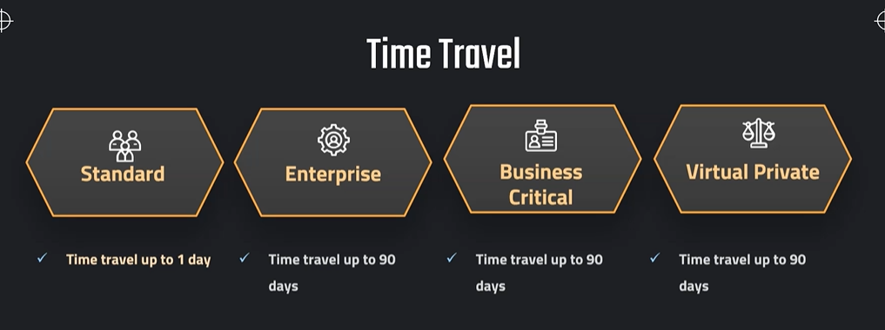

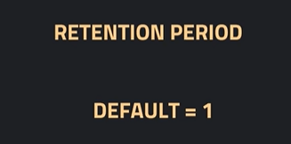

//Retention Period

SHOW TABLES like '%CUSTOMERS%';

select * from our_first_db.public.customers;

ALTER TABLE OUR_FIRST_DB.PUBLIC.CUSTOMERS
SET DATA_RETENTION_TIME_IN_DAYS = 2;

CREATE OR REPLACE TABLE OUR_FIRST_DB.public.ret_example (
id int,
first_name string,
last_name string,
email string,
gender string,
Job string,
Phone string)
DATA_RETENTION_TIME_IN_DAYS = 3;

SHOW TABLES like '%EX%';

DROP TABLE OUR_FIRST_DB.public.ret_example;
UNDROP TABLE OUR_FIRST_DB.public.ret_example;

ALTER TABLE OUR_FIRST_DB.public.ret_example
SET DATA_RETENTION_TIME_IN_DAYS = 0;

DROP TABLE OUR_FIRST_DB.public.ret_example

//Timetravel cost

SELECT * FROM SNOWFLAKE.ACCOUNT_USAGE.STORAGE_USAGE ORDER BY USAGE_DATE DESC;

SELECT * FROM SNOWFLAKE.ACCOUNT_USAGE.TABLE_STORAGE_METRICS;

// Query time travel storage
SELECT ID,
TABLE_NAME,
TABLE_SCHEMA,
TABLE_CATALOG,
ACTIVE_BYTES / (1024*1024*1024) AS STORAGE_USED_GB,
TIME_TRAVEL_BYTES / (1024*1024*1024) AS TIME_TRAVEL_STORAGE_USED_GB
FROM SNOWFLAKE.ACCOUNT_USAGE.TABLE_STORAGE_METRICS
ORDER BY STORAGE_USED_GB DESC,TIME_TRAVEL_STORAGE_USED_GB DESC;

Fail Safe
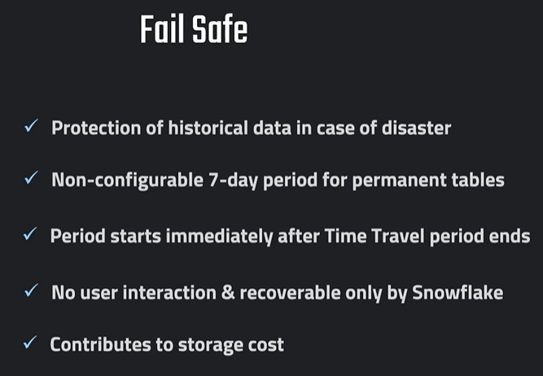

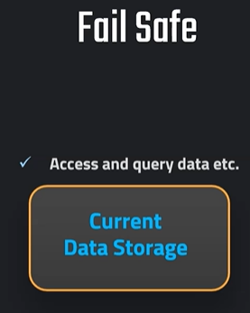

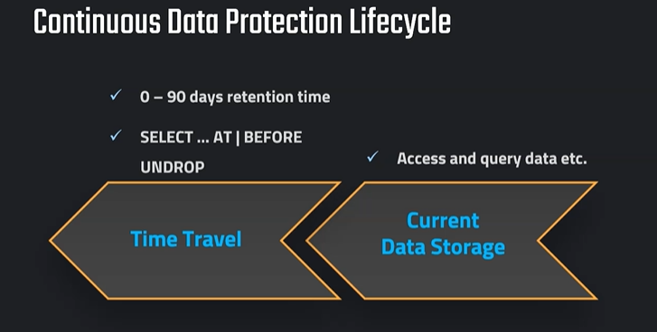

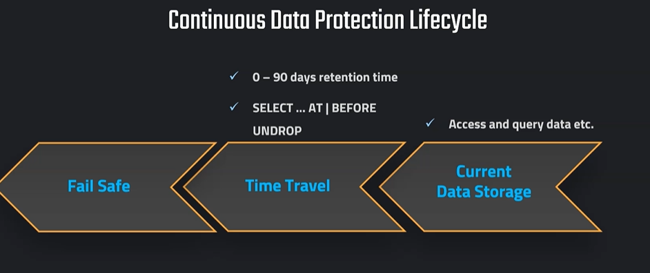

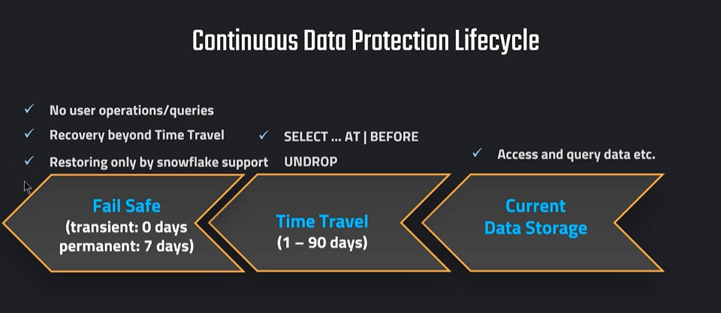

Fail-safe is a Snowflake disaster recovery feature that starts after the Time Travel period ends.
It is used by Snowflake internally to recover data in case of:
- System failures
- Data corruption
- Catastrophic issues
Unlike Time Travel, users cannot directly access or query Fail-safe data.

Difference Between Time Travel and Fail-safe
Feature | Time Travel | Fail-safe
Purpose | Recover user mistakes | Disaster recovery
User Access | Yes | No
Query Historical Data | Yes | No
Recover Dropped Table | Yes | Through Snowflake Support
Retention | 1–90 days | Additional 7 days
Editable | Yes | Read-only internal copy

Data Lifecycle in Snowflake
Active Data
↓
Time Travel Period
↓
Fail-safe (7 Days)
↓
Permanent Deletion

Explanation of “Read-only image from Fail-safe”
When data enters Fail-safe:
- Snowflake creates a read-only backup image
- Users cannot modify it
- Users cannot directly see or query it
- Only Snowflake support can restore it
Think of it like:
“Emergency recovery storage”

Real-world Example
Suppose:
- You created a table:
CREATE TABLE employees (
id INT,
name STRING
);
- You inserted data.
- Accidentally dropped the table:
DROP TABLE employees;
- During Time Travel period:
You can recover it yourself:
UNDROP TABLE employees;

But what if Time Travel expires?
Example:
- Time Travel retention = 1 day
- After 1 day passes
- Table moves to Fail-safe for 7 more days
Now:
- UNDROP will NOT work
- You cannot query historical data
- Only Snowflake Support can restore it

Important Point
Fail-safe is:
- NOT for daily recovery
- NOT for querying old data
- Mainly for emergency recovery situations

Visual Explanation
Day 1 ----------------------> Day 2 ----------------------> Day 9
Active Data Time Travel Ends Fail-safe Ends
| | |
|<---- User Recovery -->|<-- Snowflake Support -->|

Example Scenario
Step 1 — Create Table
CREATE TABLE orders (
order_id INT,
amount NUMBER
);
Step 2 — Insert Data
INSERT INTO orders VALUES
(1,100),
(2,200);
Step 3 — Drop Table
DROP TABLE orders;

Recovery Situations
Within Time Travel
UNDROP TABLE orders;
✅ User can recover

After Time Travel Ends
Table moved to Fail-safe
❌ User cannot recover directly
✅ Snowflake support may help recover

Key Interview Point
Time Travel is for user-controlled recovery.
Fail-safe is Snowflake-controlled disaster recovery.

Simple Analogy
Situation | Example
Time Travel | Undo button
Fail-safe | Disaster recovery vault

